

**(Business Analysis Report)  
 For**

**Bhangar 24 Mobile Application**

**Creative Communication for   
 Digital and Physical Media**

**Fluidscapes Consultants**

|  |  |
| --- | --- |
| Table of Contents | Page Number |
| Project Initiation | 2 |
| Introduction | 2 |
| Overview | 2 |
| Purpose | 2 |
| Project Charter | 3 |
| Identifying Stakeholders | 5 |
| Collect Requirement’s from Stakeholders | 5 |
| Planning and Research | 6 |
| Define Scope | 5 |
| Project Management Plan | 7 |
| Gantt Chart | 7 |
| KMS Project Plan and Schedule | 8 |
| KMS Phases | 10 |
| Work Breakdown Structure | 13 |
| Communication Pathway | 14 |
| Requirements | 15 |
| Dependencies | 15 |
| Define Resources | 15 |
| Technical Requirements | 16 |
| Functional Requirements | 18 |
| Project Close Off | 24 |
| Revision History | 24 |

**To** – Robin Sanyal  
**From** – Fluidscapes Technical Team  
**Subject** – Business Report Analysis for Bhangar 24  
**Date** – 31 Jan 2020

**Members Participating in the project:**Company Name – Bhangar24

|  |  |  |  |
| --- | --- | --- | --- |
| Sr No. | Name of the member | Designation | Designation & Credentials |
|  | JITENDRA SHAH | CO-FOUNDERS | MBA IN ENTREPRENEURSHIP FROM IIPM  9Yrs EXPERIENCE IN BANKING AND SALES |
|  | KRISHNA MISHRA | CO-FOUNDERS | GRADUATE IN COMMERCE  PRINTING & STATIONERY BUSINESS RAN FOR 8Yrs  RUNNING PAPER/PLASTIC SCRAP BUSINESS SINCE 2Yrs |
|  | HANSRAJ NISHAD | EXTERNAL CONSULTANT | GRADUATE IN COMMERCE  RUNNING METAL SCRAP BUSINESS SINCE 10Yrs |

**Introduction:**This document has been developed in accordance with Bhangar 24’s newly adopted “Business Case Design and Evaluation Guidelines.” The purpose of these new guidelines is to both strengthen and streamline the manner in which Bhangar 24 evaluates business cases. This in turn becomes a major driver to maximize the business value from IT investments.

The purpose of this Business Analysis Document is to assess the business value of the investment in this project proposed by Bhangar 24. Bhangar 24 offer’s Fluidscapes Consultants Pvt Ltd to be 20% shareholder in this venture. Depending upon the proposed company statistics and venture plan, Fluidscapes Consultants initiates a detailed Business Analysis report, which will help in taking the final call for the project. Bhangar 24 is a partnership firm founded by Jitendra Shah and Krishna Mishra since 11 June 2018. Both co-founders have experience in the field of sales development. The Business deals with collection of scrap and recyclables which are collected from the local scrap shops and sold to the Commission Agents. Currently Bhangar 24 are running offline business in a small geography of Virar (East & West) with approximate 80 vendors and wishes to expand in near future in cities like Mumbai, Navi Mumbai and Thane.

The target audience of Bhangar 24 is existing old Paper and Metal Marts, Households, Educational Institutions, Industrial and commercial complex and End User’s for the mobile application.

Bhangar 24 wishes to develop a mobile application which will act as an intermediary between the Channel Partners and the Households. Bhangar 24 wishes to facilitate the Channel Partner by generating opportunity for them in the form of online orders. The household users will use the mobile application for punching orders. The orders will be collected by Channel Partners only. The company Bhangar 24 wishes to make profit by collecting fee from the channel partners (Scrap Shop), by the way of revenue from the collected materials. This app will have initially two users, a) Household Users, b) Local Scrap Owners users who will send the request to the collect the scrap.

**Scope:**This document has been design to capture the business plan proposed by Bhangar 24 to develop a mobile application.   
Bhangar 24 wishes to develop a mobile application which will act as an intermediary between the Channel Partners and the Households. Bhangar 24 wishes to facilitate the Channel Partner by generating opportunity for them in the form of online orders. The household users will use the mobile application for punching orders. The orders will be collected by Channel Partners only. The company Bhangar 24 wishes to make profit by collecting fee from the channel partners (Scrap Shop), by the way of revenue from the collected materials. This app will have initially two users, a) Household Users, b) Local Scrap Owners users who will send the request to the collect the scrap.

The business model is to Act as an intermediary between the Channel Partner & The Households. Bhangar 24 will facilitate the Channel Partner by generating business opportunity for them in the form of online orders. The households will use the app for punching orders. The orders will be collected by Channel Partners only. We will purchase the materials from the Channel Partners only. Hence, Bhangar 24 will be able to earn profit in 2 ways.   
1) By way of Collection Fee from Channel Partner.   
2) By way of Revenue from the sale of collected materials.

**Business Model:**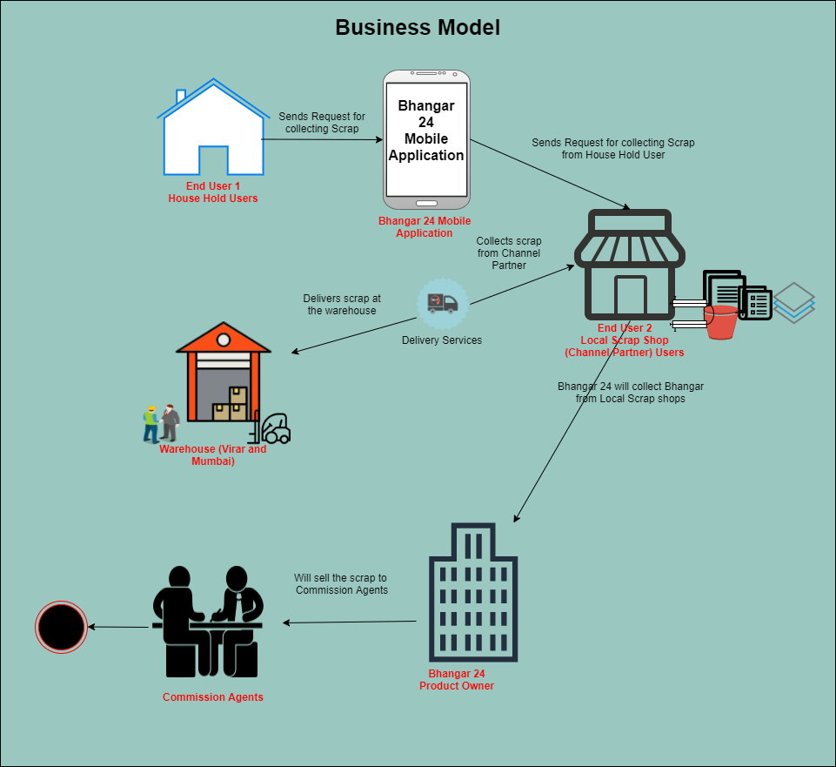

This document has been developed in accordance with Bhangar 24’s newly adopted “Business Case Design and Evaluation Guidelines.” The purpose of these new guidelines is to both strengthen and streamline the manner in which Bhangar 24 evaluates business cases. This in turn becomes a major driver to maximize the business value from IT investments.

Bhangar 24 wishes to develop a mobile application which will act as an intermediary between the Channel Partners and the Households. Bhangar 24 wishes to facilitate the Channel Partner by generating business opportunity for them in the form of online orders. The households will use the app for punching orders. The orders will be collected by Channel Partners only. Bhangar 24 wishes to purchase the materials from the Channel Partners only. The company (Bhangar 24) wishes to make profit by collecting fee from the Channel Partner’s (Scrap Shop’s), by the way of revenue from the collected materials. This app will have initially two users a. Household Users, b. Local Scrap Shop owners users who will send request to collect the scrap.

1. Household Users  
   Users will download the App on their device and create their account. This users will place request on the app to collect the scrap/recyclables which needs to be collected. The nearest scrap shop will receive the request. And once the request is received by the scrap shop owner, the scrap shop owner will collect the scrap from the house hold user.
2. Scrap shop User:  
   The scrap shop user will receive the request placed by the house hold user to collect the scrap. The scrap shop user will receive the request will give acknowledgement to the household user and according the scrap will be collected from the house hold user by the scrap shop user.

Bhangar 24 plans to sell the scrap to Commission Agents. According to Bhangar 24 Commission Agents will be able to make payment to the sold scrap immediately whereas Recycling Companies take a little long. As per Bhangar 24 Recycling Units need scrap in huge quantity which they will be able to collect and deliver over certain timeframe. Once the volumes scales up, Bhangar 24 can directly approach Recycling Units.

**Queries raised by Fluidscapes Conultants Pvt. Ltd.**

|  |  |  |
| --- | --- | --- |
|  | Mail from – Ashish Gupta, Email - [ashish.g@fluidscapes.in](mailto:ashish.g@fluidscapes.in)  Mail To – Jitendra Shah, Email - [jitendrashah80@gmail.com](mailto:jitendrashah80@gmail.com)  Wed, Nov 27, 2019 at 9:12 PM |  |
| **Sr No.** | **Query raised by Fluidscapes** | **Explanation provided by Bhangar 24** |
| 1. | The constitution of the  entity has no where been specified whether its a corporate entity or a partnership firm. | Partnership Firm 50% - 50% each |
| 2. | The time frame since the company is operating is nowhere been mentioned | Vintage Business running since 11/07/2018 |
| 3. | Existing financial position of the company is nowhere mentioned.  So how can be evaluate the share value to invest in it. | Existing Financial  Will Discuss upon Meeting. |
| 4. | Basis on which 7% net profit is been calculated on sales of all products has not been specified. | Business Gross Profit includes profit on sale of received scrap articles. It includes Paper, Plastic primarily in various categories.    Expenses includes Fixed & Variable Costs.  Godown Rent, Office Rent  Electricity Bill, Staff Salary  Transportation etc. |
| 5. | In the worksheet of "Shares" it is nowhere mentioned the rate at which 20% equity will be offered has not been mentioned. | We can Discuss upon Meeting. |
| 6. | In the worksheet of " Allocation of Funds" funds of Rs. 5 lakhs have been allocated for app development. Looking into the background of the founders, none of the founder is having a technical background. So they are entirely dependent on outside agency for technology which seems to be an integral part for this idea to work. | The co-Founders have experience in the field of sales development. They would primarily focus on Channel Partner Development. App Development needs to be accomplished by independent agency who carry forte in app development. |
| 7. | In the worksheet of " Allocation of Funds" basis of estimating the funds has not been mentioned. Also the allocation seems to be very abrupt. | All the expenses are based on factual estimates. Slight variation cannot be ruled out. |
| 8. | What is meant by "channel partner" has nowhere been mentioned. | Channel partners are local Scrap Shop Owners. |
| 9. | In the current scenario they are having only 60 channel partners which in the projections has been increased to 5000. The strategy and vision they are having for such huge increase has nowhere been specified. | Currently we are running offline business in a small geography of Virar(East & West) with approximate 80 vendors. If we consider Mumabi, Navi Mumbai & Thane as a whole .Then around 12000 such small shops exist We are focusing on 40% of existing potential initially. |
| 10. | We fail to understand the basis of sales figure ( 5000 x 50 x 12 = Rs. 30,00,00) per day. | 5000 - Channel Partner *50 - KGs collection *12 - Avg Price Of Materia 30,00,000/- Sales Per Day |
| 11. | Similarly basis of Collection Fee ( 5000 x 4 x 5 = Rs. 1,00,000) per day is beyond our understanding. | 5000 - Channel Partner *4 - No. of order per Channel Partner per day *5 - Collection Fee 1,00,000/- Collection Fee Per Day |
| 12. | Details of target customers has nowhere been mentioned. | Existing Old Paper & Metal Marts as Channel Partner. Households, Educational Institutions, Industrial & Commercial Complex as End Users for App. |
| 13. | In the end the entire proposal made is very immature and lacks the spark and details to attract any investor. |  |
| 14. | May be if the founders can incorporate further details and make the proposal a bit more presentable and realistic we can re evaluate the same. |  |

|  |  |  |
| --- | --- | --- |
|  | Mail from – Finance FSC, Email - finance@fluidscapes.in  Mail To – Jitendra Shah, Email - [jitendrashah80@gmail.com](mailto:jitendrashah80@gmail.com)  Wed, Jan 3, 2020 at 2:17 PM |  |
| **Sr No.** | **Query raised by Fluidscapes** | **Explanation provided by Bhangar 24** |
| 1. | The business model we are talking about is to bridge the gap between the households and the channel partners by acting as a collecting agent. We will purchase the scrap from households and sell it to channel partners and earn our profits in between. | The business model is to Act as an intermediary between the Channel Partner & The Households. We will facilitate the Channel Partner by generating business opportunity for them in the form of online orders The households will use our app for punching orders. The orders will be collected by Channel Partners only. We will purchase the materials from the Channel Partners only. Hence, We will be able to earn profit in 2 ways. 1)By way of Collection Fee from Channel Partner. 2)By way of Revenue from the sale of collected materials. |
| 2. | The margins are very low and to earn we need to scale up the volume tremendously. | Agreed….The margins are low but given the huge opportunity available in the market we can capitalise on that |
| 3. | The necessary infrastructures and management skills to handle such high volume low margin business needs to be discussed. | True Said….The necessary infrastructure and manpower is very crucial. We can get this fixed with proper planning for the same. We can surely discuss broadly across the table when we meet. |
| 4. | As was communicated to us in your initial email, currently your firm is operating in Virar area of Mumbai and business is completely manual operated. | Yes…We are currently operating offline from Virar only.. But having observed the opportunity for this business here in Mumbai We can surely do we. |
| 5. | With the scale of volume increasing tremendously, business needs to be automated and professionally managed considering the low margins involved. | You are absolutely right. With the increase in business volumes We need to get automation in place for smooth and unobstructed functioning. Business is smoothly manageable with manpower available for it. |
| 6. | For such automation we are completely dependent on outside agency and do not have any in house team to take care of it. | For technology we have to rely on independent agency but execution/management lies with us only. |
| 7. | Need to evaluate the uniqueness of the idea and its sustainability in the long run. | The idea is unique in terms of its freshness and viability. We will have the First Mover Advantage in this space currently. On the sustainability front, Scrap is going to get generated till the existence of mankind. Our app usage will provide the much needed comfort and convenience to the customers for dealing scrap. |
| 8. | In the initial proposal it was stated that 20% equity will be offered in lieu of investment. There are two issues in this:  a) Since the existing structure is of Partnership firm, how 20% equity will be offered we are not able to understand.  b) To quantify the value of 20% equity in monetary terms we need to have the financials before the meeting. | a) We may form a new firm and accommodate the investor accordingly. b) We have been doing transactions in cash only due to limited capital and small scale operations. |
| 9. | As per the business plan we are targeting 5000 partners who will be spread all over Mumbai. Target households will also be spread all over Mumbai. So how are we practically going to operate. Our purchase team will be purchasing the scrap from households and store it in the godowns. Then the sales team will pick it up from godowns and sale it to channel partner. For it we need to have godowns in all the areas we were are channel partners are. Cost of same is nowhere mentioned. With such low margin business all such factors will matter a lot. | Little Correction needed here We are targeting 5000 Channel Partners which we will develop within certain timeframe. As discussed in point 1,We will purchase the scrap from Channel Partners only . And they will purchase it from the orders received online as well as from offline walk-ins. We will have 2 Central Godowns in Mumbai & Virar where our recyclables will be stored. We will start with 1Godown at Virar and then depending upon the volume we will take call for the next one. Our vehicles will cover the geography in phased manner every day for collection of recyclables |
| 10. | In the initial proposal total team of 30 persons is mentioned. With 5000 channel partners and numerous households spread all over Mumbai how come the business be managed with such a small team in spite of all the automations. If employ more team cost will increase again affecting the low margin business. | We will need teams for Channel Partner Development & Operations Management. We will start with a small team initially and with the increase in volumes We will increase the numbers. We will hire females from neighbourhoods for segregation task. It will help us get low cost manpower with steady supply. The Channel Partner Development Team will get dismantled once the task is achieved. Drivers and Helpers will always be needed for taking care of collection task of recyclables. Our major focus will always lie on the development, promotion and marketing of our Online App. |

|  |  |  |
| --- | --- | --- |
|  | Mail from – Finance FSC, Email - finance@fluidscapes.in  Mail To – Jitendra Shah, Email - [jitendrashah80@gmail.com](mailto:jitendrashah80@gmail.com)  Sat, Jan 4, 2020 at 2:12 PM |  |
| **Sr No.** | **Query raised by Fluidscapes** | **Explanation provided by Bhangar 24** |
| 1. | We would be selling the scrap purchased from the channel partners to Recycling units. (We are assuming this, there is no such mention in the details so far provided) | The scrap purchased from the Channel Partner will initially be sold to the recycling units through Commission Agents.  Commission Agents make payment immediately whereas Recycling Companies take a little long. Again Recycling Units need scrap in huge quantity which we will be able to collect and deliver over certain timeframe. Once our volumes soar up scalably then we can directly approach Recycling Units. |
| 2. | Are we planning to sell the scrap to multiple recycling units?? | Once The volume get scaled up then we can sell to multiple recycling units. |
| 3. | If yes whether the logistics for the same has been worked considering the volumes we are talking about?? | For pickup of the recyclables we need 3 vehicles initially which we can use in phased manner to collect the materials. |
| 4. | Why would the channel partner be interested in selling scrap to us instead directly to the recycling units?? | The hierarchy works like this. Households - Scrap Shops - Wholesalers - Commission Agents - Recycling Units. We will provide the digital platform to households to book orders for sale of scrap. Channel Partner can not directly sell to the Recycling Units since he does not have that sizeable volume as well as Credit Bearing capacity. We will eliminate the Wholesalers initially and the Commission Agents later on. |
| 5. | How will the app be marketed so that it could reach maximum households?? Whether we will be doing the marketing by going door to door or we have some Digital Media Platform Manager who will be taking care of it?? | For marketing and promotion of the app we will utilise available platforms such as Facebook, Twitter, Whatsapp etc. Also we will run Swachh Bharat Abhiyan with schools wherein we will honour the students contributing maximum amount of recyclables during the campaign. It will help us collect good amount of recyclables for penny cost. |
| 6. | In the fund allocation sheet, Projected marketing expenses are just Rs. 75000 per month. Whether this be sufficient considering marketing of app is the most important thing for the idea to work? | Again. We can relook the marketing Strategy and work out a more cost effective and fruitful strategy. As stated, App Promotion is the most crucial aspect of this whole project and we need utmost focus for the same. |

**Revenue Model:**Rs 10/- per pick up  
Equally shared by Company & Channel Partner  
7% Net Profit on Sales across all products

**Shares:**Propose to offer 20% Equity to the Investor.

**Fund Allocation :**

|  |  |  |  |
| --- | --- | --- | --- |
| **SEGREGATION UNIT SET UP** |  |  |  |
| Godown Cost | 500000 |  |  |
| Bailing Machine(Puttha) | 350000 |  |  |
| Bailing Machine(Pet Bottle) | 350000 |  |  |
| Sorting Platform | 200000 |  |  |
| Vehicles 3 | 900000 |  |  |
| **Total 1** | 2300000 |  | 3200000 (Total 1 + Total 2) |
|  |  |  |  |
| **OFFICE & APP DEVELOPMENT** |  |  |  |
| Office Cost | 300000 |  |  |
| Computer | 100000 |  |  |
| App Development | 500000 |  |  |
|  |  |  |  |
| Total 2 | 900000 |  |  |
|  |  |  |  |
| **WORKING CAPITAL PER MONTH** |  |  |  |
| Godown Rent | 50000 |  |  |
| Office Rent | 15000 |  |  |
| Godown & Office Electricity Bill | 20000 |  |  |
| On Field Sales Staff Salary(10) | 150000 |  |  |
| On Field Purchase Staff Salary(10) | 120000 |  |  |
| Godown Staff Salary(10) | 100000 |  |  |
| IT Staff(2) | 40000 |  |  |
| Accountant & Receptionist(2) | 20000 |  |  |
| Marketing Expenses | 75000 |  |  |
| Vehicle Fuel | 120000 |  |  |
| Founder Salary | 100000 |  |  |
| Employee Welfare Fund | 20000 |  |  |
|  |  |  |  |
| Total 3 | 830000 | 6 | 4980000 (Total 3 *6) |
|  |  |  |  |
|  |  |  |  |
| **GRAND TOTAL** | **4030000** |  | 806000 (20% of 4030000) |

**Business Projection:**

|  |  |
| --- | --- |
|  | Channel Partner On Boarding & Active Business Generation From 5000 Channel Partners. |
|  | Base Of Approximate 15000 Scrap Shops spread across Mumbai & Thane. |
|  |  |
|  |  |
|  | Sales 5000*50*12=3000000/- per day |
|  | Profit Margin 3000000*7%=210000/- per day |
|  |  |
|  | Collection Fee 5000*4*5=100000/- per day |
|  |  |
| Net Profit | 210000 + 100000=310000/- per day |
|  |  |
| **Monthly Profit** | **310000 * 30 = 9300000/- per month** |

**Current Statistics:**

|  |  |
| --- | --- |
| Location | Virar (East and West) |
| No. of Channel Partners | 60 |
| Monthly Volume | 10 Lacs |
| Product | Paper & Puttha (Bund) |
| Vehicle | 1 sub-1ton vehicle |

**Pilot Project Cost:**

|  |  |
| --- | --- |
| Expenses | Amt (Rs) |
| Mobile Application Cost | Rs.1,25,000.00 |
| Online Marketing Cost for 3 Months | Rs.1,50,000.00 |
| 4 Marketing Executive Salary for 3 Months Rs. 1500*4 | Rs.1,80,000.00 |
| Tele Caller Salary for 3 Months Rs. 1200*3 | Rs.36,000.00 |
| Founder Salary for 3 Months Rs. 60000*2 | Rs.3,60,000.00 |
| Total Expense for 3 Months | **Rs.8,51,000.00** |

**Marketing Strategy:**  
1. Facebook, Twitter, WhatsApp, etc.  
2. Bhangar 24 will run Swachh Bharat Abhiyan with schools wherein Bhangar 24 will honour the students contributing maximum amount of recyclables during the campaign.  
3. Bhangar 24 is still relooking the marketing Strategy and work out a more cost effective and fruitful strategy.

## **Questions/ Constraints:**

|  |  |
| --- | --- |
| **Technical Constraints** | **Elaborated Concerns** |
| On which platform will the application be developed Android/IOS/Hybrid? | Kindly mention the platforms on which the application needs to be developed. |
| Risk’s involved while creating the mobile application | Kindly mention the technical risks/challenges involved while creating this application. |
| How the application is going to be Hosted | a. What are the security protocols?  b. Are there any other vendors that the app needs to integrate with (salesforce, SharePoint etc).  c. How is Bhangar 24 going to manage user generated content and what’s the expected upload/download shape of that content? |
| What design considerations/constraints does the mobile application have to work within? | Please share. |
| Is there a scope to have multiple releases? | Depending upon the Business Need, there could be a possibility where there could be requirement for future enhancements. Please share. |
| **Business Constraints** | **Elaborated Concerns** |
| How much will Bhangar 24 receive per order |  |
| Mention criteria’s, set KPI’s on weight, per order basis, |  |
| If monthly, then as per subscription? If yes define subscription criterias. |  |
| Can we receive list of channel partners? |  |
| Who will the app compete with? | Bhangar 24 needs to do a detailed evaluation of competitors.  Although Bhangar 24 claims to be one of its kind to introduce this app in the market, thorough market analysis to be done. |

**SWOT Analysis:**